**NFCSD Art Educators**

**Grade PreK & Kindergarten**

**Earth Art Self-Portrait**

**To Know:**

**Self Portrait** is a fancy art-word for a picture of yourself. Many famous works of art are self-portraits that the artists makes of themselves.

**Earth art** is an art movement in which landscape and the work of art are intricately linked. It is

also an [art](http://en.wikipedia.org/wiki/Art) form that is created in [nature](http://en.wikipedia.org/wiki/Nature), using [natural materials](http://en.wikipedia.org/wiki/Natural_materials) such as [soil](http://en.wikipedia.org/wiki/Soil), [rock](http://en.wikipedia.org/wiki/Rock_(geology)) (bed rock, boulders, stones…), organic media (logs, branches, [leaves](http://en.wikipedia.org/wiki/Leaf)…), and [water](http://en.wikipedia.org/wiki/Water). Sculptures are not placed in the landscape; rather, the landscape is altered to be the creation. Part of the fun of being an **environmental artist** is to leave a “Happy Surprise” for someone else to come along and find, like many environmental and street artists of the world do.

**Optional further study:** search the Earth Art of *Andy Goldsworthy or the portraits of Giuseppe Arcimboldo, and Jane Perkins*

**Supplies:** Stuff you can find from nature, like pebbles, sticks, grass, leaves, flowers…

**Optional Supplies:** Something to hold the items you collect; to move them to where you are creating. A cell phone to take a picture of your creation if you want a keepsake of your work.

**To Do:**

*Take a walk in your yard, around your neighborhood, or at a park (go with a grown-up and remember to be at a safe distance, like 6 feet or more from others). Look for things that interest you (consider their *shape*, *color*, and *texture*), and find shapes that would be good for different parts of your face and head. (optional: It might be helpful to take a really good look in a mirror before you go so you can notice the shapes in your face and remember better for later.)

*Find a good spot to create your self-portrait. At the park, your neighborhood, even on your front lawn, or somewhere around your house, wherever you think people will see it without it getting in the way.

**Mission Accomplished:**

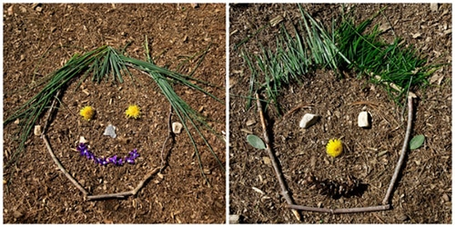When you’ve used all kinds of things

you’ve found in nature to make a your

self-portrait look just like you